[**Creating Java web service using Axis 2 and Tomcat**](http://www.compiletimeerror.com/2013/09/creating-java-web-service-using-axis-2.html)

**Web Service:**  
A Web Service is a code that is exposed over the network and can be invoked using HTTP.  
  
**Why Web Service:**  
Using web service your functionality can be exposed to rest of the world. Web service uses SOAP to transport data. It is a open protocol. With web service the functionality can be consumed from different platforms. For example you can create a web service in your windows computer and that can be consumed from your android mobile.  
  
Using web service you can create a loosely coupled client server environment. Which means, when the server code is changed it is not always necessary to change the client code.  
  
**Axis 2**  
Axis 2 is a web service/SOAP/WSDL engine provided by Apache. It is a java based implementation. Axis 2 provides complete object model and modular architecture. Using Axis 2 you can easily create a web service from a plain java class, send SOAP messages, receive SOAP message.  
  
Creating a web service from a plain java class in eclipse:  
  
  
  
**Step 1:**  
Before creating a project you need to add axis 2 dependencies to your eclipse.  
To do so, download axis 2 from this website <http://axis.apache.org/axis2/java/core/> .  
Open your eclipse and go to Window>Preferences

[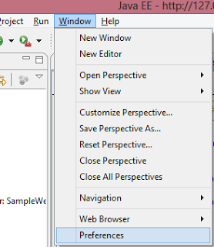](http://2.bp.blogspot.com/-mQ7PtmNP0M8/UjqGklr-MkI/AAAAAAAAAMc/15QJ8hVYUnc/s1600/1.png)

Expand Web Services option and click Axis2 Preferences.  
Give your axis2 location in the Axis2 runtime l oocation box:

[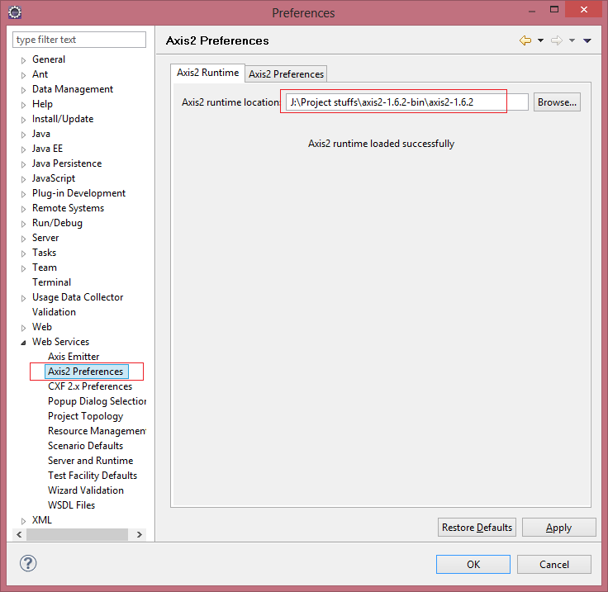](http://2.bp.blogspot.com/-S92vLKrHyFc/UjqGoBF1jvI/AAAAAAAAAMk/v0U6y_JMkM8/s1600/2.png)

Click OK.  
  
**Step 2:**  
You have added Axis2 runtime to you eclipse. Now you can create your web service.  
Go to File>New>Dynamic web project

[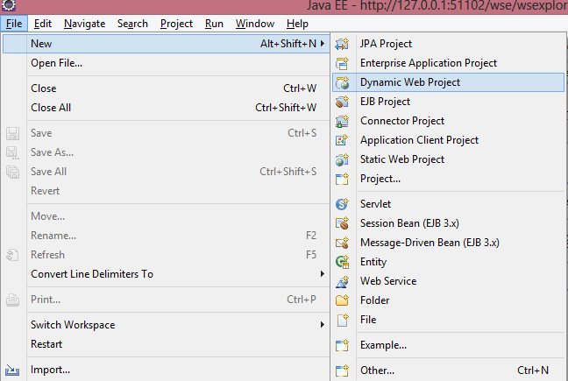](http://2.bp.blogspot.com/-eXlAfi_3oGQ/UjqHovJ1P8I/AAAAAAAAAM4/jTkZuImseis/s1600/3.png)

Give any project name and select Dynamic web module version 2.5. Dynamic web module 3 is not compatible with Axis 2.

[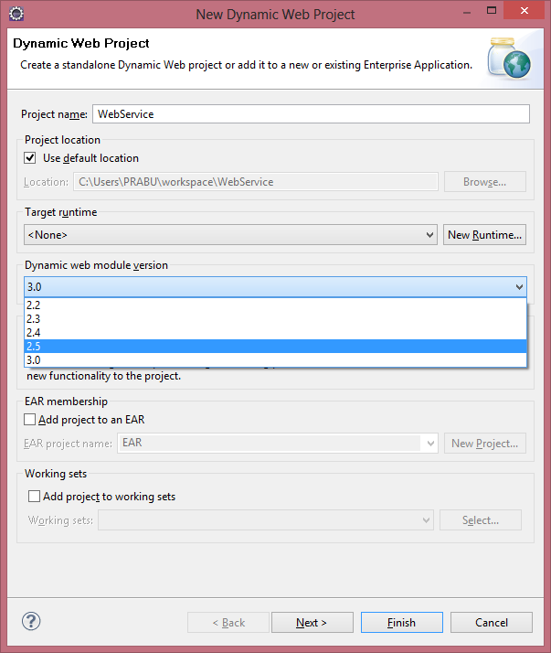](http://1.bp.blogspot.com/-TewhzZfS9rg/UjqHlp0zKEI/AAAAAAAAAMw/kZgvWyAg_PU/s1600/4.png)

Now click finish.  
  
**Step 3:**  
Goto project properties and select Axis 2 facet.

[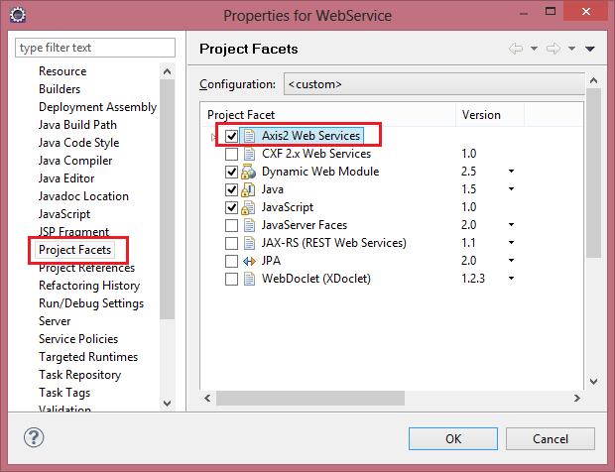](http://2.bp.blogspot.com/-XZ10Wi6uLp0/UjqLYTb7eKI/AAAAAAAAANo/6y9xiX1alVQ/s1600/11.png)

Click OK. Now Axis 2 libraries will be imported to your project.  
  
**Step 4:[--­­**  
Now expand your project window>right click on src>New>Package

[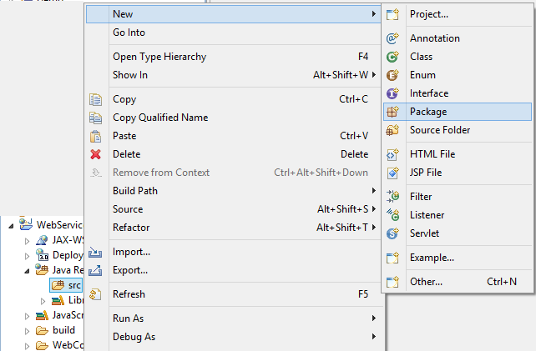](http://4.bp.blogspot.com/-TKjHjky0_Eo/UjqImr9P8bI/AAAAAAAAANE/W2wVNxd-d1s/s1600/5.png)

Give any name to the package;

[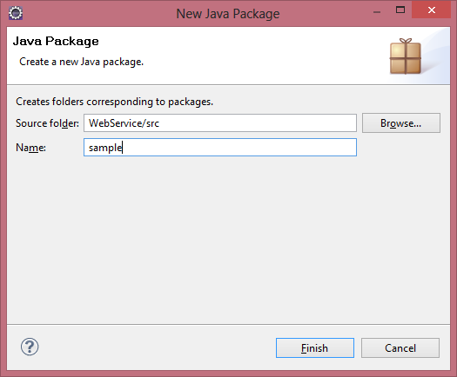](http://1.bp.blogspot.com/-8LkVm9Bedio/UjqI0Cz4Q9I/AAAAAAAAANM/mHVX4bspSeE/s1600/6.png)

Now click finish.  
  
**Step 5:**  
Create a new java class inside the newly created package:

[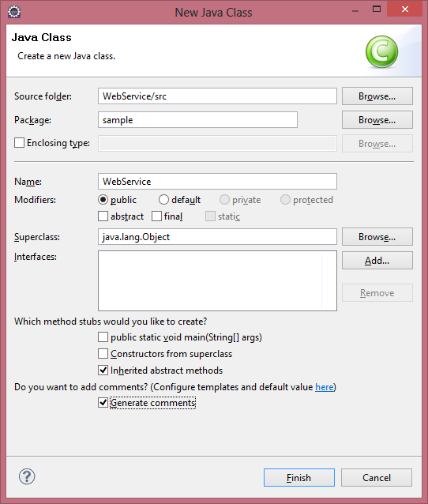](http://1.bp.blogspot.com/-6b-ZojnW-tU/UjqJPjc6FwI/AAAAAAAAANU/tcNWoMz2uwg/s1600/7.png)

**Step 6:**

Create a simple method which returns a String

/**

*

*/

**package** sample;

/**

* @author Vienna

*

*/

**public** **class** **WebService** {

**public** String **getName**(){

**return** "Test";

}

}

And save the class.

**Step 7:**

Now right click on the java class>Web Services>Create new web service

[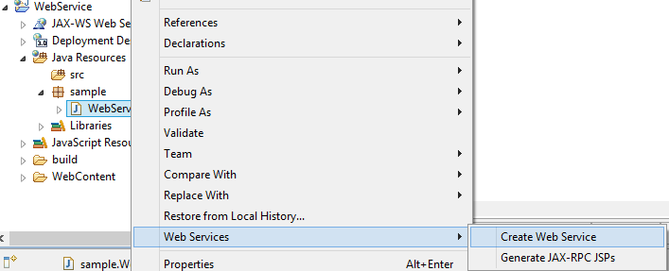](http://2.bp.blogspot.com/-v6TKoeK2Qeg/UjqJ5qtjjzI/AAAAAAAAANc/p_8HrYqcB3E/s1600/8.png)

**Step 8:**  
Make sure that correct class name is selected in the Service implementation box.  
In the configuration>Web service runtime> Make sure Axis 2 is selected. If it is different then click the name and a new window will be opened.

[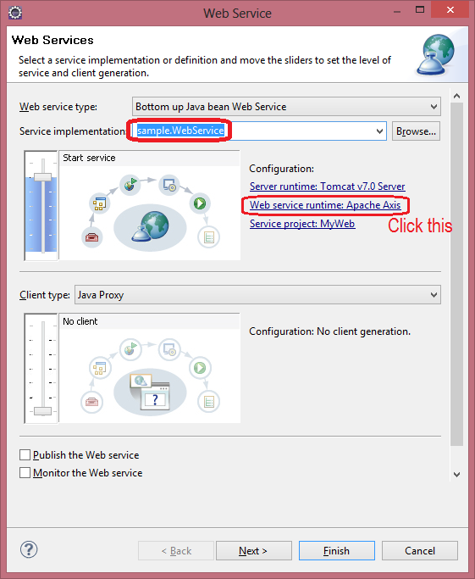](http://4.bp.blogspot.com/-4XCL9WB-FoE/UjqMomgJWaI/AAAAAAAAAN0/kUGVe5s1CFU/s1600/9.png)

In the new window select Axis2

[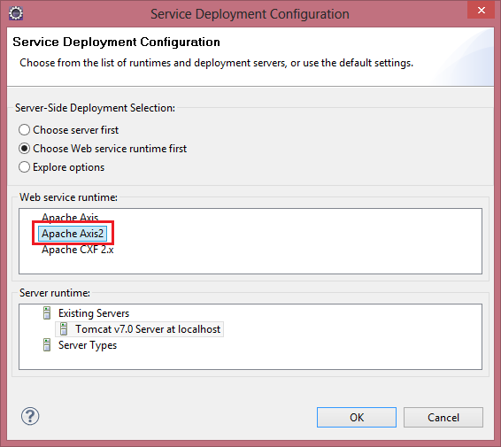](http://3.bp.blogspot.com/-p65xIv1C8ec/UjqMxNoglOI/AAAAAAAAAN8/s0fRuXmyNNw/s1600/10.png)

 Now click OK and finish the setup.  
  
**Step 9:**  
Publish your project in Tomcat.

[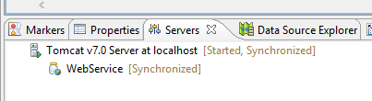](http://4.bp.blogspot.com/-m-s1CUh3Imk/UjqNW_XF4mI/AAAAAAAAAOE/VKxeItePYCw/s1600/12.png)

**Step 10:**  
Run your project on tomcat.  
To run the project Right click on the project name>Run as>Run on server>Select Tomcat>Click finish.  
Now Axis home will be opened.

[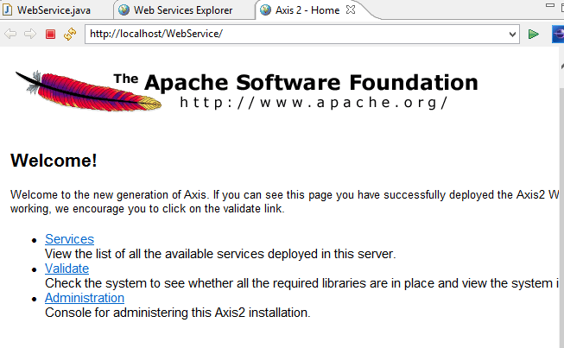](http://4.bp.blogspot.com/-XyyjkNBBXtA/UjqP_PcPXZI/AAAAAAAAAOs/HjXUgHCx02A/s1600/17.png)

Now click "Services"  
Under Web Service, your project url and the method you have created in the java class will be displayed. And the Service status should be active.

[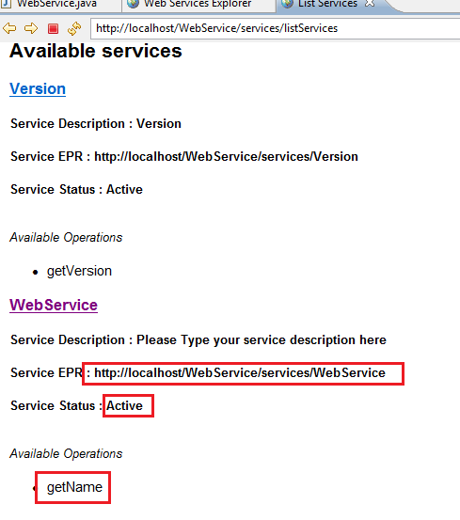](http://4.bp.blogspot.com/-cI4eUI0GXZs/UjqQpm6g5CI/AAAAAAAAAO0/Vh7RHIoepnE/s1600/18.png)

Now click Web Service, wsdl file will be displayed. Copy the URL of the WSDL file

[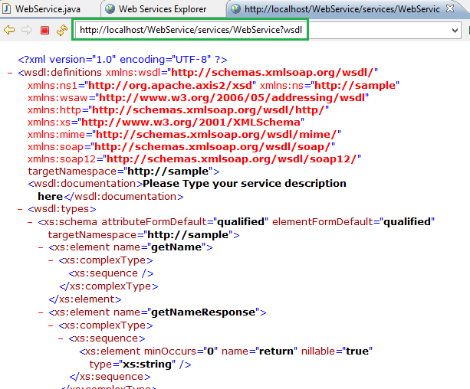](http://1.bp.blogspot.com/-bmmSaMlb9OM/UjqRMIShOeI/AAAAAAAAAO8/BARYNzjZUJ0/s1600/19.png)

**Step 11:**  
Click web services explorer at the top of tool bar.

[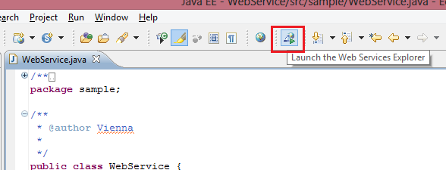](http://3.bp.blogspot.com/-uACrN6zzmpg/UjqOCCWGzzI/AAAAAAAAAOM/vF5zFvi-ZLY/s1600/13.png)

**If this is not available in the tool bar then,**  
Right click on the tool bar and select customize perspective

[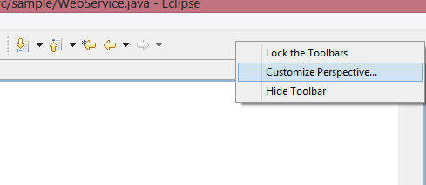](http://3.bp.blogspot.com/-gRRfDiGD9Lc/UjqObx5ucRI/AAAAAAAAAOU/rx66BUBSQ7Q/s1600/14.png)

Now make sure that the "Launch Web Services Explorer" check box is checked and click OK

[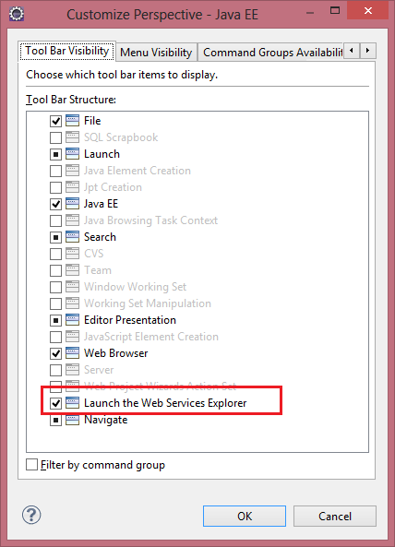](http://4.bp.blogspot.com/-nabfiXx6boA/UjqO88ZIiZI/AAAAAAAAAOg/AVJqHCVOwaI/s1600/15.png)

After adding this "Web Services Explorer", Open it.  
Click WSDL page icon at the right corner of the wen services explorer window

[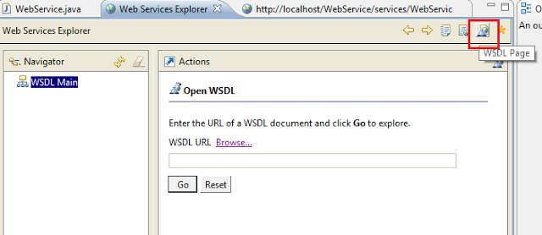](http://2.bp.blogspot.com/-lZQIU38nmjs/UjqRvzwH6-I/AAAAAAAAAPE/VBS_ErPzyCE/s1600/20.png)

**Step 12:**  
Paste the WSDL url and click GO.  
Your web service will be added to UDDI and it will be listed under UDDI registry.

[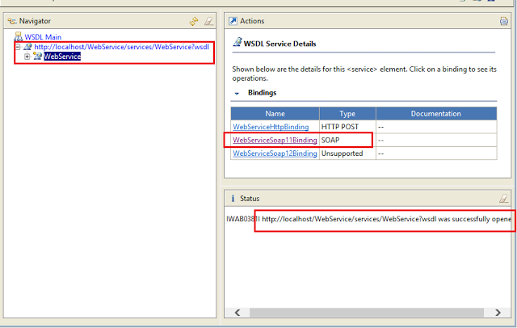](http://4.bp.blogspot.com/-plUfsnF5tM8/UjqSmHSTx5I/AAAAAAAAAPM/7qmrKema-F0/s1600/21.png)

**Step 13:**  
Expand your project  name and click WebServiceSoap11Binding  
The method name will be displayed at the right side

[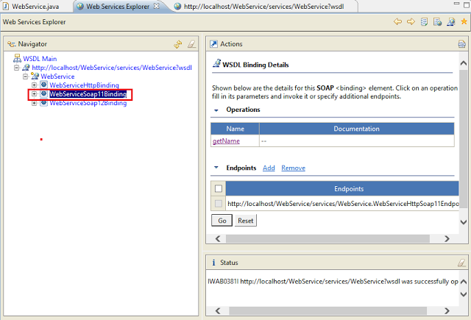](http://1.bp.blogspot.com/-YBEggrtYE5Q/UjqTQAp4IzI/AAAAAAAAAPU/2eH9CvaCbZg/s1600/22.png)

**Step 14:**  
Click the method name displayed at the right side.

[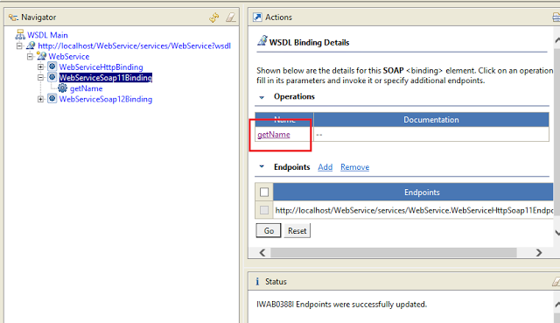](http://4.bp.blogspot.com/-D9vSp8lkbYo/UjqTozR7xJI/AAAAAAAAAPc/JJBuneScrgc/s1600/23.png)

Now click "GO"

[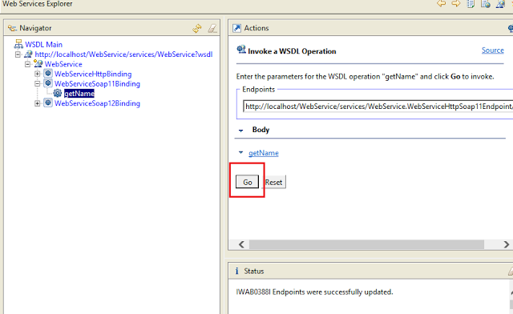](http://4.bp.blogspot.com/-EnMT7TjZQFg/UjqT6LX-7rI/AAAAAAAAAPk/h1MVPyu0pbk/s1600/24.png)

**Step 15:**  
Now you should be seeing the String value returned by you method in the status window.

[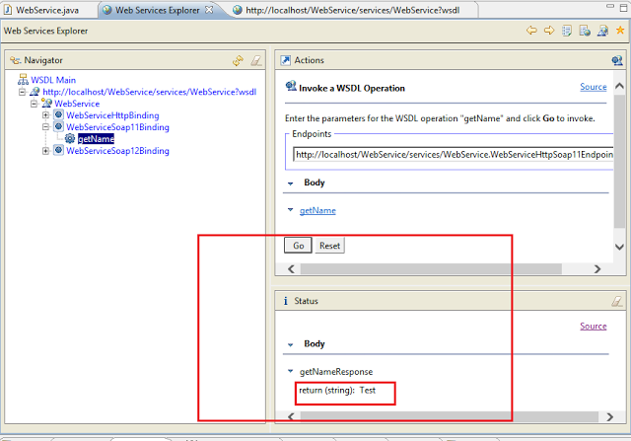](http://1.bp.blogspot.com/-mPaM66cbsLE/UjqUVr49QyI/AAAAAAAAAPs/sPMiweNkHJU/s1600/25.png)

**Step 16:**  
You have created your web service. You can use it in your other applications.